Analysis of Indian Restaurant in New York City
Geetu Bhadauria
March 25, 2020
1. Introduction
1.1 Background
New York is one of the top foodie destinations in the United States. Some would even say that this bustling island is home to some of the best food in the world. But within that, which spots are crafting unforgettable dishes that deserve a place on your gastronomy bucket list?
Indian food has slowly but surely found its way into the hearts (and stomachs) of cities around the United States. There are more than 300 restaurants that serve cuisine from across the subcontinent in New York City alone, according to Krishnendu Ray, a professor at New York University who has been studying the cuisine's rise for more than a decade. Compare that to the mere 20 Indian restaurants that could be found in the Big Apple in the early 1980s.
1.2 Objective
Objective of this project is to list and visualize all major parts of New York City that has great Indian restaurants.
1.3 Interest
There are various people may be interested in this Project or Analysis and can utilize the result. List includes tourist visiting to New York city, people living in New Yorks, new people shifted to in and around the city, bloggers who are interested to write their blog about food or restaurants, food channels and many more.

2. Data acquisition
2.1 Data Sources

New York City data that contains list Boroughs, Neighborhoods along with their latitude and longitude.
Data source : https://cocl.us/new_york_dataset

Description : This data set contains the required information. And we will use this data set to explore various neighborhoods of New York city.

Indian restaurants in each neighborhood of New York city.
Data source : Foursquare API
Description : By using this api we will get all the venues in each neighborhood. We can filter these venues to get only Indian restaurants.

GeoSpace data
Data source https://data.cityofnewyork.us/City-Government/Borough-Boundaries/tqmj-j8zm
Description : By using this geospace data we will get the New York Borough boundaries that will help us visualize choropleth map.

3. Methodology
After getting data and from https://cocl.us/new_york_dataset and https://data.cityofnewyork.us/City-Government/Borough-Boundaries/tqmj-j8zm created a dataframe for new_york_data and visualized number of neighborhood for each borough in New York city.
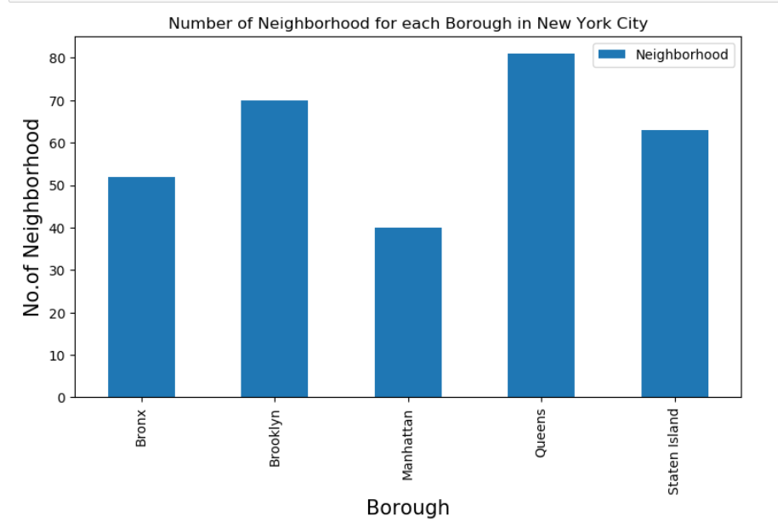
Figure 1
With the help of column in new York data named category as 'Indian Restaurant' sorted out the list of Indian Restaurant in each borough.
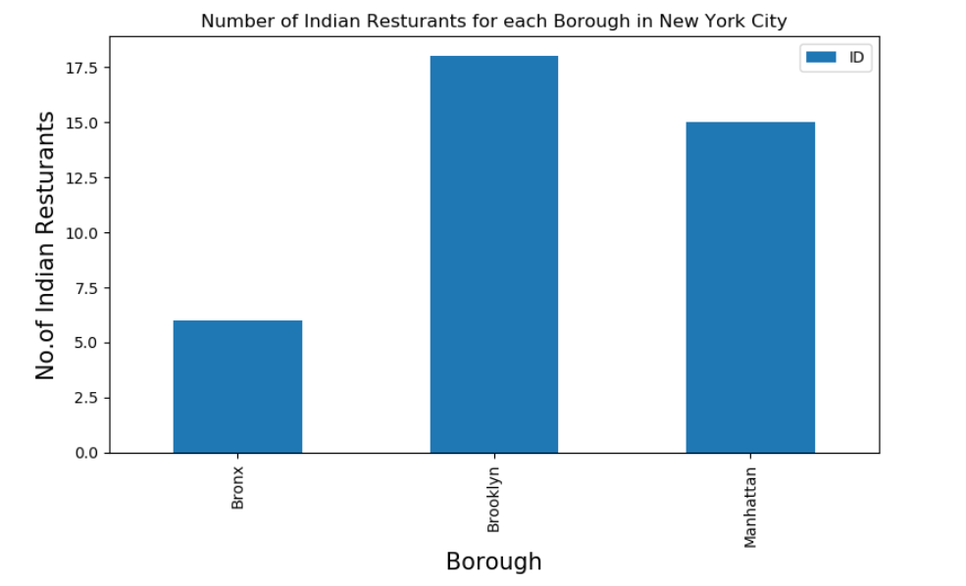
Figure 2
Then made list of Indian Restaurants to identify the neighborhood which has maximum Indian restaurants. And found that 'Upper West Side' has maximum Indian Restaurants.
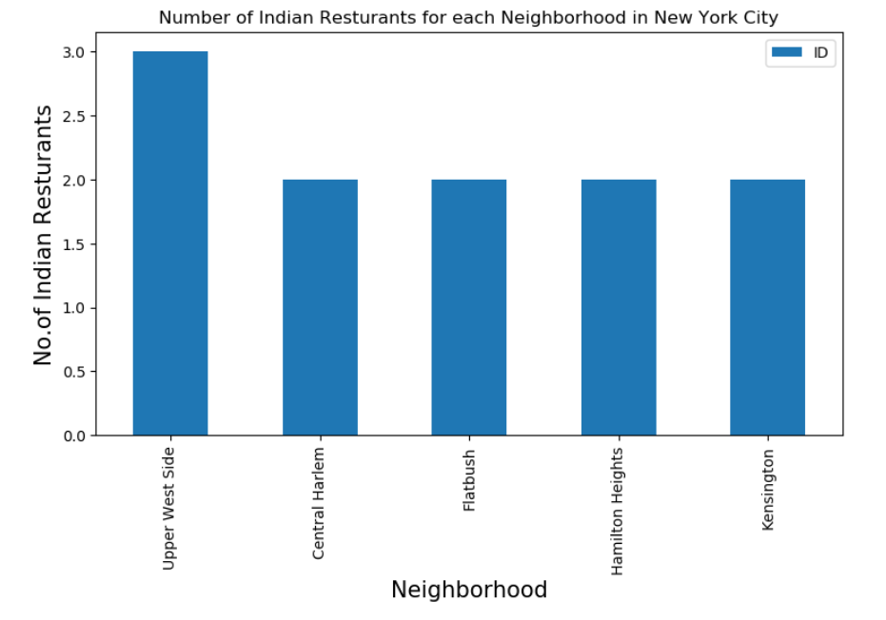
Figure 3
Further Analysis includes to check average ratings, number of likes of restaurants to give better picture to select the restaurant.
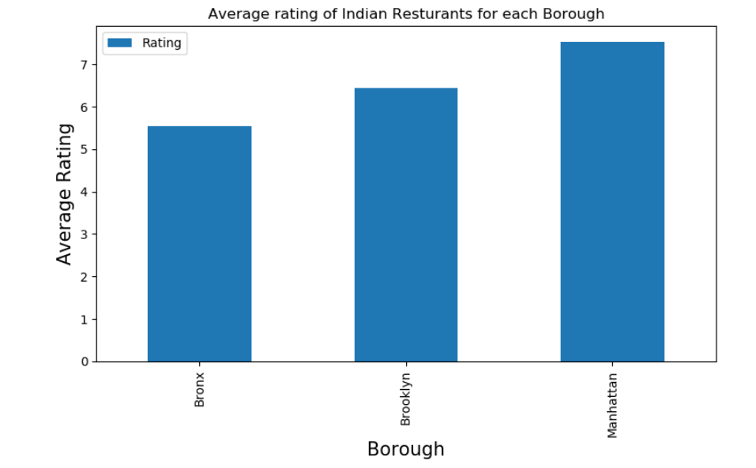
Figure 4
4. Results
The results are carried out to give the answer of the following questions:
What is the best location in New York City for Indian Cuisine?
Which areas have a potential Indian Restaurant Market?
Which are some of the best neighborhoods for Indian cuisine?
Which is the best place to stay if you prefer Indian Cuisine?

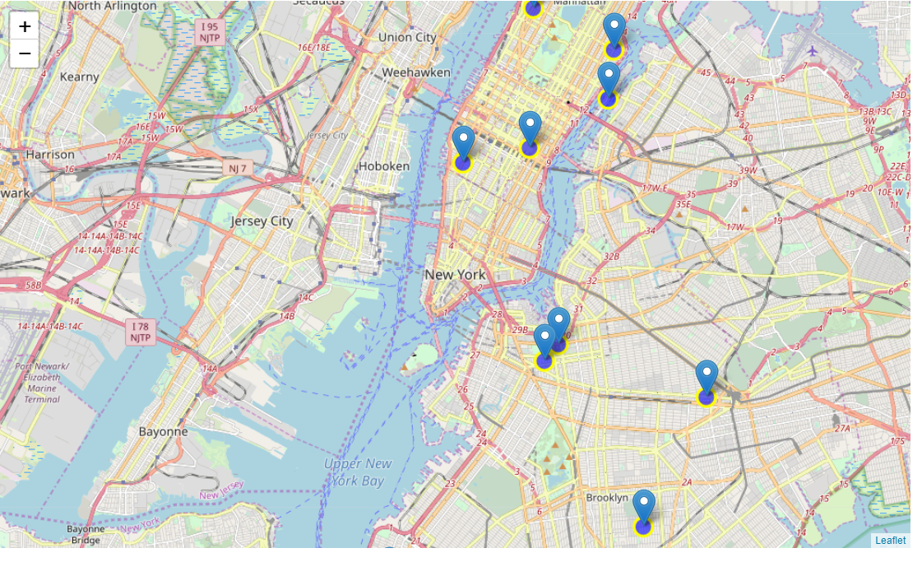
Figure 5 Map of New York showing Indian Restaurants Location
5. Discussion
The analysis has been carried out to list and visualize all major parts of New York City that has great Indian restaurants. The restaurant with various attributes like maximum likes, rating and tips is also provided. The accuracy of data is completely depends on the data provided by FourSquare.
6. Conclusion
- Brooklyn has the largest number of Indian Restaurants.
- The Upper west side in Brooklyn has the highest number of restaurants i.e. 3.
- Bay Ridge (Brooklyn), Central Harlem (Manhattan), Clinton Hill (Brooklyn) are some of the best neighborhoods for Indian cuisine.
- Manhattan and Brooklyn are the best places to stay if you prefer Indian Cuisine. Though Manhattan ranks first and Brooklyn ranks second in ranking ; the difference in their average rating is minimal i.e. Manhattan is with 7.83 and Brooklyn is with 7.82.
7. References
For this project I used some notes from the IBM Data Science Labs.
The Foursquare API documentation was also used to pull together this project.

